According to Intelli, the Europe Cardiology Devices Market was valued at approximately **USD 15823.33 million** in 2024 and is projected to reach **USD** 28762.73 **million** by 2032, growing at a **compound annual growth rate (CAGR) of 6.71%** during the forecast period (2024–2032).

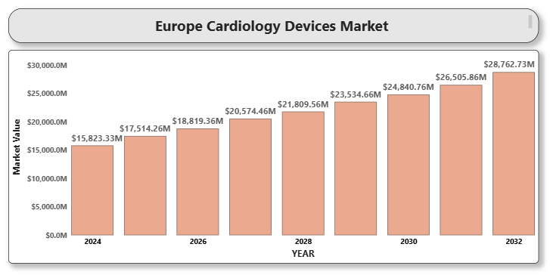

**Europe Cardiology Devices Market Definition**

Cardiology devices refer to a broad range of diagnostic and therapeutic equipment used in the prevention, monitoring, and treatment of cardiovascular diseases. These devices include pacemakers, defibrillators, cardiac monitors, stents, catheters, and heart valves. The demand for such technologies continues to grow across Europe due to rising cardiovascular disease burden and advances in minimally invasive cardiac care.

**Europe Cardiology Devices Market Overview**

The European region is witnessing an upsurge in cardiovascular disease prevalence, which continues to be a leading cause of mortality and morbidity. Aging demographics, sedentary lifestyles, and dietary habits contribute significantly to the growing need for effective cardiac care solutions. Moreover, countries like Germany, France, and the UK are front-runners in adopting cutting-edge cardiology devices due to supportive public health policies, advanced infrastructure, and collaborative clinical research initiatives. The integration of AI and real-time data analytics in cardiac monitoring and interventional devices is further enhancing clinical outcomes.

**Europe Cardiology Devices Market Segmentation Analysis**

The Europe Cardiology Devices Market is segmented based on Product Type, Application, End-user, and Geography.

**Europe Cardiology Devices Market By Product Type:**

* Diagnostic and Monitoring Devices
  + ECG DevicesA close-up of hands holding a tablet and a pen

    Description automatically generated
  + Holter Monitors
  + Event Monitors
  + Implantable Loop Recorders
* Therapeutic and Surgical Devices
  + Pacemakers
  + Defibrillators
  + Cardiac Resynchronization Therapy (CRT) Devices
  + Catheters and Stents
  + Heart Valves

Implantable devices such as pacemakers and defibrillators dominate the market due to their efficacy in treating arrhythmias and preventing sudden cardiac arrest. However, diagnostic monitoring devices are witnessing rapid adoption driven by the need for continuous and remote patient monitoring.

**Europe Cardiology Devices Market By Application:**

* Coronary Artery Disease
* Heart Failure
* Arrhythmia
* Hypertension
* Others

The increasing incidence of coronary artery disease and arrhythmias is expected to propel the demand for interventional cardiology products such as stents and cardiac rhythm management devices.

**Europe Cardiology Devices Market By End-user:**

* Hospitals
* Cardiology Clinics
* Ambulatory Surgical Centers
* Homecare Settings

Hospitals account for the largest market share due to their ability to perform high-complexity procedures. However, ambulatory and homecare settings are expanding due to portable monitoring systems and patient-centered care trends.

**Europe Cardiology Devices Market, By Country:**

* Germany
* UKA close-up of hands holding a tablet and a pen

  Description automatically generated
* France
* Italy
* Spain
* Rest of Europe

Germany leads the cardiology devices market in Europe, supported by its advanced healthcare system, robust research infrastructure, and early adoption of next-generation devices. France and the UK are close competitors due to growing government initiatives and increasing investments in digital cardiovascular health.

**Key Players** Prominent players in the Europe Cardiology Devices Market include:

* Medtronic
* Abbott Laboratories
* Boston Scientific Corporation
* Biotronik
* Edwards Lifesciences Corporation

**Key Developments**

* In September 2024, Medtronic plc, a prominent medical technology name, launched its new ECMO system called VitalFlow. A versatile, one-box solution, VitalFlow prioritizes ease of use and optimal performance. It improves the ECMO process by integrating bedside treatment with in-hospital transport, giving healthcare providers a more seamless and sophisticated user experience.Abbott launched a next-gen wireless pacemaker platform in the UK and Germany.
* In 2024, the European market for cardiology devices saw significant growth in wearable and remote monitoring technologies. The intelligent devices, with AI-based analytics, enabled uninterrupted, real-time monitoring of heart rate, rhythm, and oxygen saturation.
* In 2025, Edwards Lifesciences received EU approval for a novel mitral valve repair system.

**Market Attractiveness** Western Europe remains the most lucrative market, driven by high procedure volumes and favorable reimbursement policies. Meanwhile, Eastern Europe is showing potential growth with increasing healthcare investments and improved access to cardiac care.

**Porter’s Five Forces**

* Threat of New Entrants – Moderate due to regulatory and technological entry barriers
* Bargaining Power of Buyers – High owing to consolidated healthcare systems
* Threat of Substitutes – Low due to the critical nature of cardiac devices
* Bargaining Power of Suppliers – Moderate
* Competitive Rivalry – High among top global players with continual innovation

**TABLE OF CONTENT**

**1. INTRODUCTION OF EUROPE CARDIOLOGY DEVICES MARKET**

1.1 Overview of the Market

1.2 Scope of Report

1.3 Assumptions

**2. EXECUTIVE SUMMARY**

**3. RESEARCH METHODOLOGY**

3.1 Data Mining

3.2 Validation

3.3 Primary Interviews

**4. EUROPE CARDIOLOGY DEVICES MARKET OUTLOOK**

4.1 Overview

4.2 Market Dynamics

4.3 Drivers

4.4 Restraints

4.5 Opportunities

4.6 Trends

4.7 Porters Five Force Model

4.8 Value Chain Analysis

**5. EUROPE CARDIOLOGY DEVICES MARKET, BY PRODUCT TYPE**

5.1 Diagnostic and Monitoring Devices

5.2 Therapeutic and Surgical Devices

**6. EUROPE CARDIOLOGY DEVICES MARKET, BY APPLICATION**

6.1 Coronary Artery Disease

6.2 Heart Failure

6.3 Arrhythmia

6.4 Hypertension

6.5 Others

**7. EUROPE CARDIOLOGY DEVICES MARKET, BY END-USER**

7.1 Hospitals

7.2 Cardiology Clinics

7.3 Ambulatory Surgical Centers

7.4 Homecare Settings

**8. EUROPE CARDIOLOGY DEVICES MARKET, BY COUNTRY**

8.1 Germany

8.2 UK

8.3 France

8.4 Italy

8.5 Spain

8.6 Rest of Europe

**9. EUROPE CARDIOLOGY DEVICES MARKET COMPETITIVE LANDSCAPE**

9.1 Company Market Ranking

9.2 Key Development Strategies

**10. COMPANY PROFILES**

1. **Medtronic**
2. Overview
3. Financial Performance
4. Product Outlook
5. Key Developments
6. **Abbott Laboratories**
7. Overview
8. Financial Performance
9. Product Outlook
10. Key Developments
11. **Boston Scientific Corporation**
12. Overview
13. Financial Performance
14. Product Outlook
15. Key Developments
16. **Biotronik**
17. Overview
18. Financial Performance
19. Product Outlook
20. Key Developments
21. **Edwards Lifesciences Corporation**
22. A close-up of hands holding a tablet and a pen

    Description automatically generatedOverview
23. Financial Performance
24. Product Outlook
25. Key Developments

**11. KEY DEVELOPMENTS**

1. Product Launches/Developments
2. Mergers and Acquisitions
3. Business Expansions
4. Partnerships and Collaborations

**12. APPENDIX**

12.1 Related Research